### 

### **CONTRIBUTION - SARATHRAJ R**

### **Product Dissection for Spotify**

#### **Company Overview**

Spotify, founded in 2006 by Daniel Ek and Martin Lorentzon, is a leading audio streaming platform that has revolutionized how people access and enjoy music, podcasts, and audiobooks. With a mission to "unlock the potential of human creativity," Spotify connects artists with listeners worldwide through a user-friendly interface and powerful personalization features. Available in over 180 countries, Spotify’s freemium model and innovative algorithms have made it a dominant player in the music streaming industry, boasting millions of active users globally.

### **Product Dissection and Real-World Problems Solved by Spotify**

Spotify addresses several real-world challenges through its innovative features, creating a seamless and engaging audio streaming experience. By leveraging advanced algorithms and a robust platform, Spotify tackles issues related to content discovery, accessibility, and artist exposure, fostering a vibrant ecosystem for both listeners and creators.

1. **Personalized Music Discovery** Spotify’s recommendation algorithms, such as Discover Weekly and Release Radar, analyze user listening habits to curate personalized playlists. This solves the problem of navigating an overwhelming catalog of millions of songs, helping users discover music tailored to their tastes.
2. **Accessibility Across Devices** Spotify’s cross-platform availability (mobile, desktop, smart devices) and offline listening feature ensure users can enjoy music anytime, anywhere, addressing the challenge of limited access to music on the go.
3. **Artist Exposure and Monetization** Spotify empowers independent artists by providing a platform to upload and distribute their music globally. Through features like Spotify for Artists, creators gain insights into listener demographics and streaming data, solving the problem of limited exposure for emerging talent.
4. **Social Sharing and Collaboration** Spotify allows users to share playlists, follow friends, and collaborate on shared playlists, fostering a sense of community and addressing the challenge of disconnected music experiences in a digital age.

In summary, Spotify’s innovative features address real-world challenges by making music and audio content accessible, discoverable, and shareable, while supporting artists in reaching global audiences.

### **Case Study: Real-World Problems and Spotify’s Innovative Solutions**

Spotify has redefined the audio streaming landscape by addressing key challenges faced by listeners and creators. Below, we explore specific problems and how Spotify’s features provide effective solutions.

#### **Problem 1: Overwhelming Choice in Music Discovery**

**Real-World Challenge**: With millions of songs available, users often struggle to find music that aligns with their preferences, leading to decision fatigue and disengagement.

**Spotify’s Solution**: Spotify’s Discover Weekly and Daily Mix playlists leverage machine learning to analyze listening history, genre preferences, and user behavior. These curated playlists introduce users to new artists and songs tailored to their tastes, reducing choice overload and enhancing engagement. Additionally, the "Explore" section and "Radio" feature generate algorithm-driven recommendations, making discovery intuitive and enjoyable.

#### **Problem 2: Limited Access to Music on the Go**

**Real-World Challenge**: Users often face barriers to accessing music due to internet connectivity issues or device limitations, restricting their ability to enjoy content seamlessly.

**Spotify’s Solution**: Spotify’s offline listening mode allows premium users to download songs and podcasts for playback without an internet connection. Cross-platform synchronization ensures a consistent experience across devices, such as smartphones, desktops, and smart speakers, solving accessibility challenges and providing uninterrupted access.

#### **Problem 3: Barriers for Independent Artists**

**Real-World Challenge**: Emerging artists struggle to gain visibility and monetize their work in a competitive industry dominated by major labels.

**Spotify’s Solution**: Through Spotify for Artists, the platform provides tools for creators to upload music, track performance metrics, and connect with fans. Features like playlist pitching and algorithmic recommendations amplify exposure, enabling independent artists to reach global audiences and build sustainable careers.

#### **Problem 4: Lack of Social Connection in Music Experiences**

**Real-World Challenge**: Music consumption can feel isolating in the digital age, with limited opportunities for shared experiences.

**Spotify’s Solution**: Spotify’s social features, such as collaborative playlists and the ability to follow friends or artists, foster community engagement. Users can share tracks or playlists via social media or messaging apps, creating shared music experiences that bridge the gap between digital and personal connections.

**Conclusion**: Spotify’s user-centric approach addresses key challenges in music discovery, accessibility, artist exposure, and social engagement. By combining cutting-edge technology with intuitive features, Spotify has created a platform that enhances the listening experience and supports the global music ecosystem.

### **Top Features of Spotify**

1. **User Profiles**: Users create personalized profiles with usernames, profile pictures, and listening activity, allowing them to showcase their music preferences and follow others.
2. **Playlists**: Users can create, share, and collaborate on playlists, curating collections of songs and podcasts for personal or social use.
3. **Tracks and Albums**: The core of Spotify’s content, tracks and albums include metadata like artist, genre, and release date, enabling seamless organization and discovery.
4. **Recommendations**: Algorithms like Discover Weekly and Release Radar suggest content based on user behavior, enhancing music discovery.
5. **Offline Mode**: Premium users can download tracks and podcasts for offline playback, ensuring accessibility without internet connectivity.
6. **Spotify for Artists**: A suite of tools for artists to upload music, monitor analytics, and engage with fans.

### **Schema Description**

The schema for Spotify is designed to support its core functionalities, including music streaming, playlist creation, recommendations, and artist analytics. Below are the key entities, attributes, and relationships.

#### **User Entity**

Represents Spotify users (listeners or artists).

* **UserID** (Primary Key): Unique identifier for each user.
* **Username**: User’s chosen display name.
* **Email**: User’s email for account communication.
* **Profile_Picture_URL**: URL of the user’s profile image.
* **Subscription_Type**: Free or Premium status.
* **Registration_Date**: Date the user joined Spotify.

#### **Track Entity**

Represents individual songs or podcast episodes.

* **TrackID** (Primary Key): Unique identifier for each track.
* **Title**: Name of the track.
* **ArtistID** (Foreign Key referencing Artist Entity): The artist who created the track.
* **AlbumID** (Foreign Key referencing Album Entity): The album the track belongs to.
* **Genre**: Genre of the track (e.g., Pop, Jazz).
* **Duration**: Length of the track in seconds.
* **Stream_Count**: Number of times the track has been streamed.
* **Release_Date**: Date the track was released.

#### **Album Entity**

Represents collections of tracks (e.g., music albums or podcast series).

* **AlbumID** (Primary Key): Unique identifier for each album.
* **Title**: Name of the album.
* **ArtistID** (Foreign Key referencing Artist Entity): The artist who created the album.
* **Release_Date**: Date the album was released.

#### **Playlist Entity**

Represents user-curated or algorithm-generated playlists.

* **PlaylistID** (Primary Key): Unique identifier for each playlist.
* **UserID** (Foreign Key referencing User Entity): The user who created the playlist.
* **Title**: Name of the playlist.
* **Creation_Date**: Date the playlist was created.
* **Is_Collaborative**: Boolean indicating if the playlist allows collaboration.

#### **PlaylistTrack Entity**

Associates tracks with playlists.

* **PlaylistTrackID** (Primary Key): Unique identifier for each association.
* **PlaylistID** (Foreign Key referencing Playlist Entity): The playlist.
* **TrackID** (Foreign Key referencing Track Entity): The track included in the playlist.

#### **Artist Entity**

Represents musicians or podcast creators.

* **ArtistID** (Primary Key): Unique identifier for each artist.
* **Name**: Artist’s name.
* **Bio**: Brief description of the artist.
* **Follower_Count**: Number of users following the artist.

#### **Follow Entity**

Represents user-artist or user-user follow relationships.

* **FollowID** (Primary Key): Unique identifier for each follow relationship.
* **FollowerUserID** (Foreign Key referencing User Entity): The user following.
* **FollowedUserID** (Foreign Key referencing User Entity) or **FollowedArtistID** (Foreign Key referencing Artist Entity): The user or artist being followed.
* **Follow_Date**: Date the follow relationship was established.

#### **Relationships**

* **Users create Playlists**: A user can create multiple playlists.
* **Playlists contain Tracks**: A playlist can include multiple tracks, and a track can appear in multiple playlists.
* **Artists create Tracks and Albums**: An artist can produce multiple tracks and albums.
* **Users follow Artists or other Users**: A user can follow multiple artists or users, and artists/users can have multiple followers.
* **Tracks belong to Albums**: A track is associated with one album, but an album can contain multiple tracks.

### **Rationale Behind the Design**

The schema is designed to support Spotify’s core objectives: seamless content delivery, personalized recommendations, and artist engagement.

* **Scalability**: Entities like Tracks and Playlists are designed to handle millions of records, with foreign keys ensuring efficient querying.
* **Flexibility**: The PlaylistTrack entity allows dynamic playlist creation, supporting both user-curated and algorithm-generated playlists.
* **Personalization**: User and Track entities include attributes (e.g., Genre, Stream_Count) that feed into recommendation algorithms.
* **Artist Support**: The Artist entity and Spotify for Artists features enable analytics and exposure, aligning with Spotify’s mission to empower creators.  
   This structure ensures efficient data retrieval, supports real-time recommendations, and accommodates Spotify’s freemium model.

### **ER Diagram**

The ER diagram visually represents the schema, illustrating entities (User, Track, Album, Playlist, PlaylistTrack, Artist, Follow) and their relationships. Key relationships include:

* One-to-Many: User to Playlist (one user creates many playlists).
* Many-to-Many: Playlist to Track via PlaylistTrack (playlists contain multiple tracks, and tracks appear in multiple playlists).
* One-to-Many: Artist to Track/Album (one artist creates many tracks/albums).
* Many-to-Many: User to Artist/User via Follow (users follow multiple artists/users).

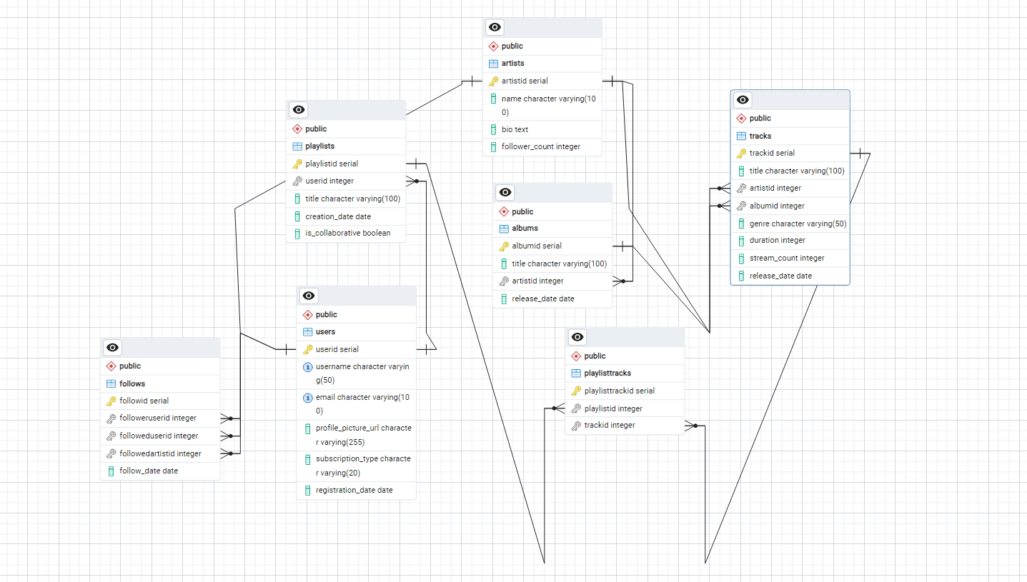

### **Presentation of Findings**

Spotify’s schema design is a robust foundation for its functionality, enabling seamless music streaming, personalized recommendations, and artist engagement. The User, Track, and Playlist entities capture the platform’s core features, while relationships like PlaylistTrack and Follow support dynamic interactions. The schema’s scalability and flexibility align with Spotify’s goals of delivering a user-centric experience and fostering creativity. By organizing data efficiently, Spotify ensures fast content retrieval and supports its recommendation algorithms, driving user satisfaction and platform growth.

**This case study demonstrates Spotify’s ability to address real-world challenges through innovative features and a well-designed schema. By understanding its data architecture, we gain insights into how Spotify delivers a seamless, personalized, and community-driven audio streaming experience.**